A wireframe is a simplified, visual representation of a webpage, app, or digital interface. It outlines the basic structure, layout, and key elements without including detailed design features like colors, fonts, or images. Wireframes act as a blueprint, helping designers, developers, and stakeholders plan the user experience (UX) and functionality before moving to high-fidelity designs. (Guilizzoni, 2025)

The wireframe of my entire project is attached below

Figure 1 Wireframe 1

Figure 2 Wireframe 2

Figure 3 Wireframe 3

Figure 4 Wireframe 4

Figure 5 Wireframe 5

Figure 6 Wireframe 6

Figure 7 Wireframe 7

Figure 8 Wireframe 8

Figure 9 Wireframe 9

Figure 10 Wireframe 10

Figure 11 Wireframe 11

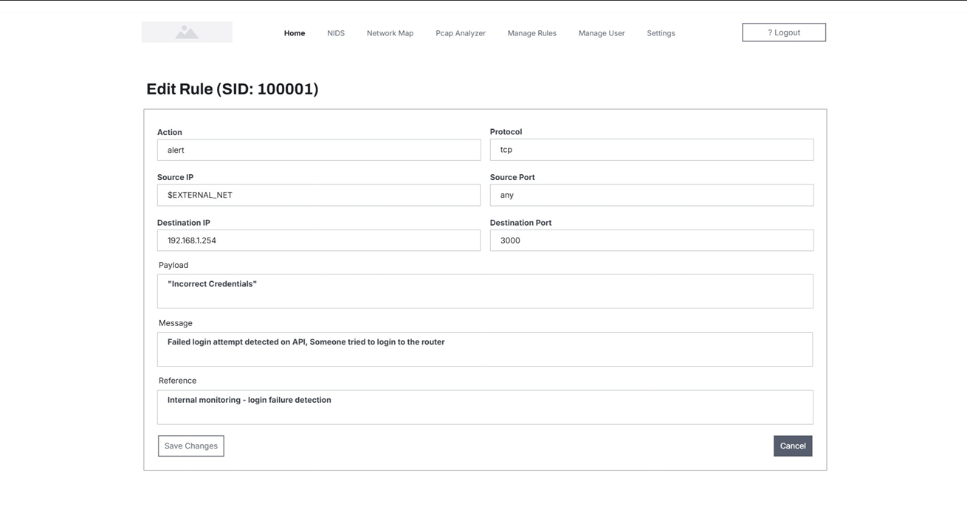

Figure 12 Wireframe 12

Figure 13 Wireframe 13

Figure 14 Wireframe 14

Figure 15 Wireframe 15